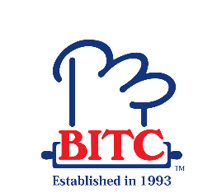
COURSE SCHEDULE - DIPLOMA IN HOSPITALITY (CAFÉ OPERATIONS)
Module Titles | Module Start Date | Module End Date
Food & Beverage Operations | 18.01.2021 | 05.02.2021
College Vacation (08.02.2021 to 19.02.2021)
Pastry and Baking Techniques | 22.02.2021 | 12.03.2021
Business Operations | 15.03.2021 | 05.04.2021
Hospitality Marketing | 06.04.2021 | 26.04.2021
Communication Skills for Hospitality | 27.04.2021 | 18.05.2021
Academic & Research Skills | 19.05.2021 | 09.06.2021
Food & Beverage Operations | 10.06.2021 | 30.06.2021
College Vacation (01.07.2021 to 11.07.2021)
Pastry and Baking Techniques | 12.07.2021 | 02.08.2021
Business Operations | 03.08.2021 | 24.08.2021
Hospitality Marketing | 25.08.2021 | 14.09.2021
Communication Skills for Hospitality | 15.09.2020 | 05.10.2021
Academic & Research Skills | 06.10.2021 | 26.10.2021
Food & Beverage Operations | 27.10.2021 | 17.11.2021
Business Operations | 18.11.2021 | 08.12.2021
Hospitality Marketing | 09.12.2020 | 29.12.2021

