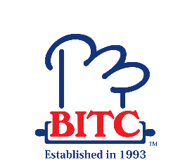
COURSE SCHEDULE - DIPLOMA IN HOSPITALITY MANAGEMENT (PATISSERIE & BAKING)
Module Titles | Module Start Date | Module End Date
Food & Beverage Operations | 18.01.2021 | 05.02.2021
College Vacation (08.02.2021 to 19.02.2021)
Service Marketing | 22.02.2021 | 12.03.2021
Tourism & Hospitality Industry | 15.03.2021 | 05.04.2021
Business Communication | 06.04.2021 | 26.04.2021
Principles of Cake Making | 27.04.2021 | 18.05.2021
Principles of Bread Making | 19.05.2021 | 09.06.2021
Principles of Pastry Making | 10.06.2021 | 30.06.2021
College Vacation (01.07.2021 to 11.07.2021)
Service Marketing | 12.07.2021 | 02.08.2021
Tourism & Hospitality Industry | 03.08.2021 | 24.08.2021
Business Communication | 25.08.2021 | 14.09.2021
Principles of Cake Making | 15.09.2020 | 05.10.2021
Principles of Bread Making | 06.10.2021 | 26.10.2021
Principles of Pastry Making | 27.10.2021 | 17.11.2021
Service Marketing | 18.11.2021 | 08.12.2021
Tourism & Hospitality Industry | 09.12.2021 | 29.12.2021

